Training Dataset & Training Report

Prepared By – Mandar Vilas Ukrulkar / 11-08-26
#

Name: dataset_v16v2_200726.clean.canonical.jsonl
Model target: Qwen3.5-4B financial-table-structure analyst (LoRA fine-tune, adapter Qwen3.5-4B_v16v2_clean_dataset_210826_v2)
Dataset file: dataset_v16v2_200726.clean.canonical.jsonl (6,109 records, ~100 MB)
Source corpus: C:\Users\mandar.ukrulkar\Downloads\data_raw_in_out_jsons_200726\output (the same job-output snapshot used to build the pre-canonicalization dataset)
Training code: VM_training_scripts/main_v2.py
Report generated: 2026-08-11

1. Executive summary
Metric | Value
Source documents processed | 249 unique financial-statement documents (+3 re-run twice, +1 non-classification QA job)
Total tables detected by the parser | 19,821
Tables classified as *financial* (candidates for labeling) | 6,260
Tables skipped as non-financial (TOC, prose, boilerplate) | 13,532 (68%)
Raw compiled dataset (dataset_v16v2_200726.jsonl) | 6,289 records
De-duplicated clean dataset (*.clean.jsonl) | 6,109 records (180 removed, 2.9%)
Canonicalized dataset (*.clean.canonical.jsonl) | 6,109 records — 0 removed, value-level relabeling only
Cells/fields remapped by canonicalization | table_type 420, concept_id 820, concept_meaning 2,742, unit 1,175, scale_multiplier 64,730
Distinct table_type label strings | 2,087 (down from 2,232 pre-canonicalization, −6.5%)
Median table shape | 11 rows × 4 columns (unchanged by canonicalization)
Median prompt / completion length | 2,225 / 9,040 characters
Fine-tuning method | LoRA (r=32, alpha=64) on Qwen/Qwen3.5-4B, 1× NVIDIA L4 GPU, bf16
Training run | 3 epochs / 363 steps, effective batch 48, ~11.4 hours
Held-out evaluation | 5% split (306 samples), evaluated every 40 steps — best checkpoint kept by eval_loss
Final training loss (epoch 3 mean) | ~0.124
Final eval loss / eval token accuracy | 0.137 / 96.55%

The training set is built from the same real financial-statement tables (10-Ks, 20-Fs, annual reports, insurance/bank filings) as the *.clean.jsonl dataset, but with an added canonicalization pass that normalizes table_type, concept_id, unit, scale_multiplier, and concept_meaning values before fine-tuning. Unlike the sibling adapter trained on *.clean.jsonl (main.py, no eval split), this run holds out 5% of the data for genuine generalization tracking.

2. How this report was produced
Three data sources were combined:
- Source job outputs — C:\Users\mandar.ukrulkar\Downloads\data_raw_in_out_jsons_200726\output (253 job folders), the exact snapshot dataprep_140726.py compiled from. Unchanged from the *.clean.jsonl report — reproduced in §3 for a self-contained document.
- The compiled/cleaned training files — dataset_v16v2_200726.jsonl (raw) and dataset_v16v2_200726.clean.jsonl (de-duplicated), used here only as the "before" side of the canonicalization diff.
- The canonical training file and its transform log — dataprep/dataset_v16v2_200726.clean.canonical.jsonl (via dataprep/canonicalize_dataset.py) and dataprep/../report_assets/canonicalization_report.json, analyzed directly for §4 and the EDA in §5.
Provenance check: canonicalization changes field *values* inside existing records — it does not add, remove, or re-key records. dataset_v16v2_200726.clean.canonical.jsonl and dataset_v16v2_200726.clean.jsonl both contain exactly 6,109 records, confirmed by direct line count of both files. §3's job/document ledger therefore applies unchanged to this dataset.

3. Source corpus

3.1 Job-level overview
Total processing jobs | 253
— classification jobs (ai_provider: azure) | 251
— non-classification QA/extraction jobs (no labeling) | 2
Unique source documents | 249 (+3 documents each re-run through the pipeline twice)
Tables per job (table_count) — median / mean / max | 64 / 79.0 / 691
Financial tables per job — median / mean / max | 11.5 / 25.0 / 222

Every classification job used the same pipeline configuration (ai_provider: azure, classified: true). The two non-classification jobs were extraction-only test runs against the same QA file and contributed zero labeled tables.

3.2 Documents by number of labeled financial tables
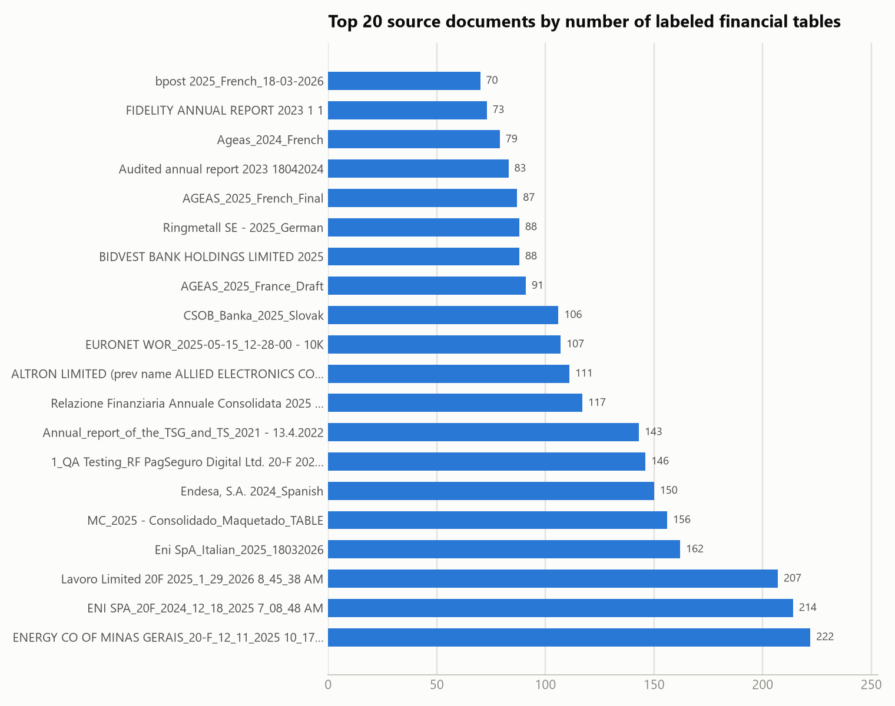
The corpus is dominated by long-form annual filings — 20-F filings and full annual reports (Eni, ENI SPA, Lavoro, Energy Company of Minas Gerais, Endesa, MC Group) each contribute 150–222 tables, an order of magnitude more than a typical single-country statutory filing (~10–30 tables).

3.3 Table-count distribution across the corpus
Heavily right-skewed: 62% of documents (156 of 250) contribute fewer than 20 financial tables; a long tail of 12 large multi-jurisdiction filings each contribute 100+.

4. From source tables to training set
Parser output (job dirs) 19,821 tables detected
└─ financial-table filter → 6,260 tables classified as financial
└─ dataprep_140726.py → 6,289 (prompt, completion) records → dataset_v16v2_200726.jsonl
└─ dataset_clean.py (near-duplicate table_type resolution)
└─ 6,109 records → dataset_v16v2_200726.clean.jsonl
└─ canonicalize_dataset.py (value-level normalization, no records dropped)
└─ 6,109 records → dataset_v16v2_200726.clean.canonical.jsonl ← used for training
canonicalize_dataset.py does not touch record count — it relabels field *values* on the same 6,109 records that dataset_clean.py produced:
- table_type: 420 cells remapped, collapsing 2,232 → 2,087 distinct label strings.
- concept_id: 820 cells remapped, 67,473 → 67,134 distinct values.
- concept_meaning: 2,742 cells remapped — for a concept_id where one free-text meaning holds ≥60% share among its variants, all variants are canonicalized to that dominant meaning. 1,676 concept_ids were resolved this way; 17,211 remain ambiguous (no dominant meaning) and were left as-is — e.g. the concept_id "Total" alone has 365 distinct free-text meaning variants across 579 occurrences.
- unit: 1,175 cells remapped via a 3-entry alias map (percentage→percent, EUR_thousand/thousand euro→thousand EUR), reducing 210 → 188 distinct units. 32 additional mixed-scale unit variants (e.g. million HUF, EUR_thousand, billion_cubic_meter) were flagged but not auto-fixed and remain separate strings.
- scale_multiplier: 64,730 cells standardized down to 10 canonical multiplier values (1000, 1000000, 1, 0.01, 1000000000, 100, and four rare fractional values).

5. EDA — canonical training dataset (6,109 records)

5.1 table_type label distribution
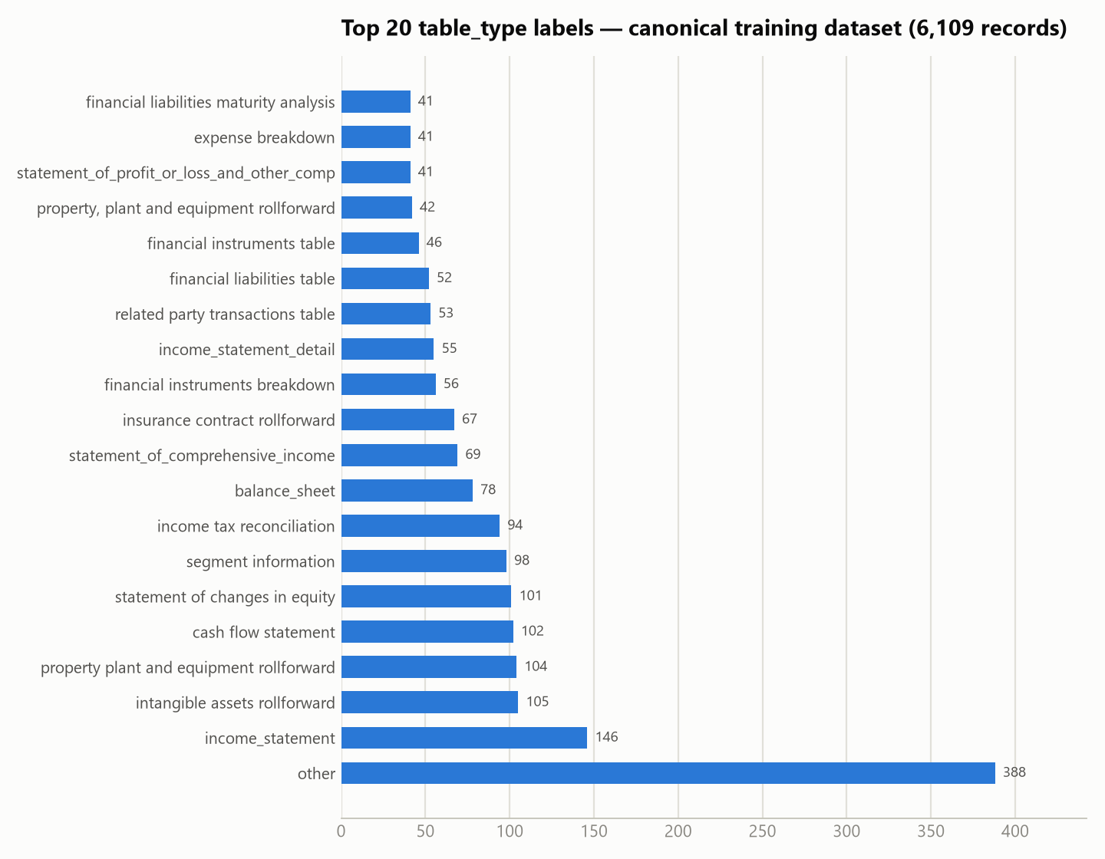
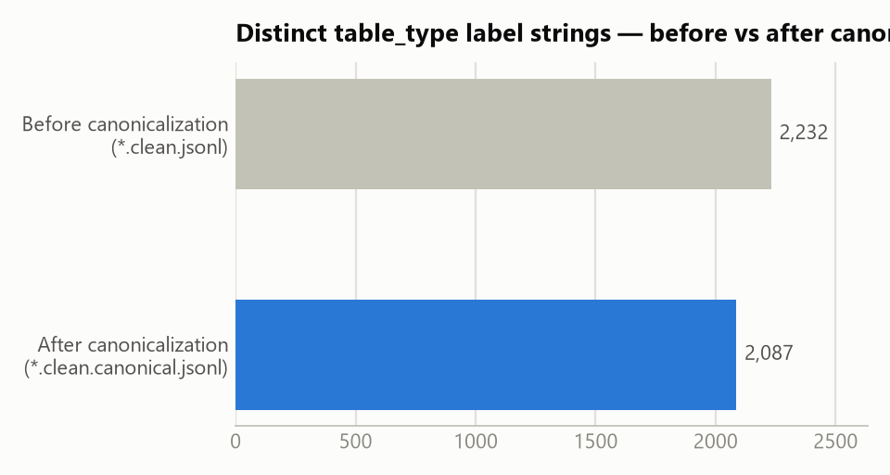
- 2,087 distinct label strings across 6,109 records (down from 2,232 pre-canonicalization) — canonicalization closed 145 near-duplicate label variants, but the taxonomy is still effectively open-vocabulary/free-text rather than a fixed enum.
- other remains the single largest bucket, consistent with the pre-canonicalization distribution — tables the labeler couldn't map to a specific known statement type.
- Beyond the top ~20, the distribution still has a very long tail: most distinct labels occur only 1–3 times, so canonicalization narrows but does not solve the low-example-count problem for most specific table types.

5.2 Table shape
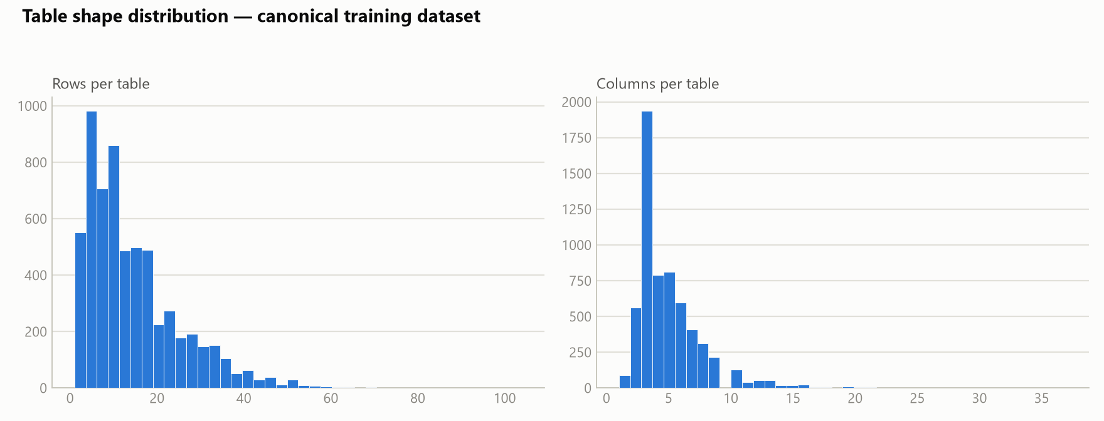
 | min | p25 | median | mean | p75 | p90 | p99 | max
Rows/table | 1 | 6 | 11 | 14.4 | 20 | 30 | 50 | 104
Columns/table | 1 | 3 | 4 | 4.9 | 6 | 8 | 16 | 37
Cells/table | 0 | 12 | 24 | 35.0 | 47 | 82 | 156 | 285

Identical to the pre-canonicalization dataset — canonicalization only rewrites table_type/concept_id/unit/scale_multiplier/concept_meaning values, not table dimensions.

5.3 Row and column semantic composition
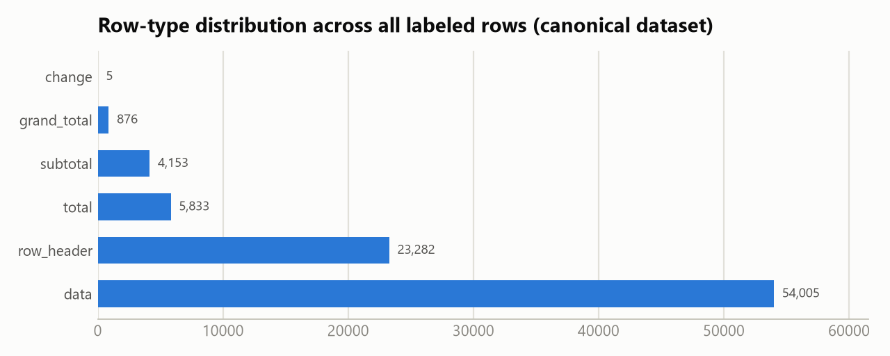
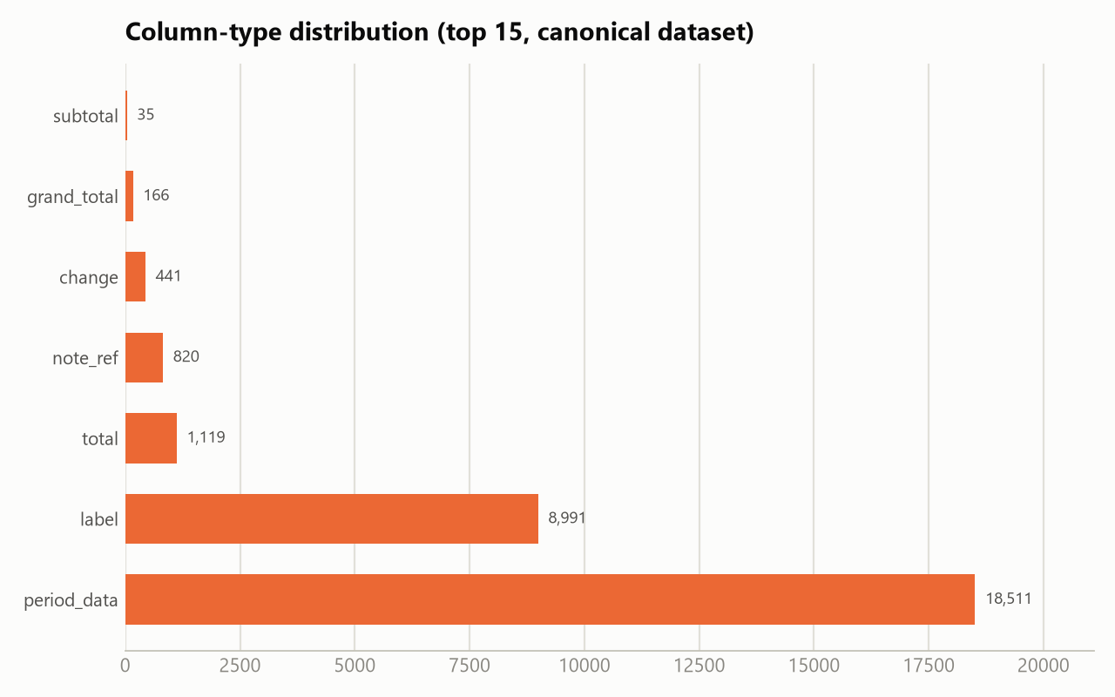
Across all 6,109 tables, labeled rows total 88,154 and columns 30,083:
Row type | Count | Share
data | 54,005 | 61.3%
row_header | 23,282 | 26.4%
total | 5,833 | 6.6%
subtotal | 4,153 | 4.7%
grand_total | 876 | 1.0%
change | 5 | <0.1%

Column type | Count | Share
period_data | 18,511 | 61.5%
label | 8,991 | 29.9%
total | 1,119 | 3.7%
note_ref | 820 | 2.7%
change | 441 | 1.5%
grand_total | 166 | 0.6%
subtotal | 35 | 0.1%

Row/column type counts are byte-for-byte identical to the pre-canonicalization dataset, confirming canonicalize_dataset.py left structural row/column typing untouched.

5.4 Prompt / completion length
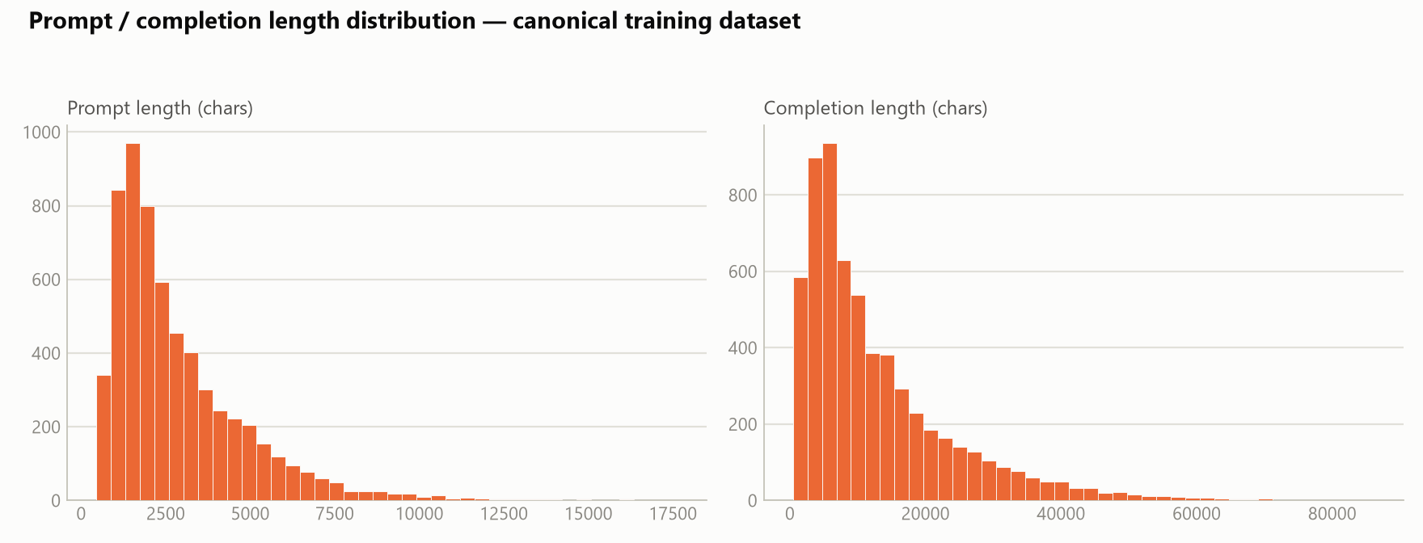
 | min | p25 | median | mean | p75 | p90 | p99 | max
Prompt (chars) | 443 | 1,437 | 2,225 | 2,859 | 3,720 | 5,472 | 10,055 | 17,648
Completion (chars) | 427 | 4,807 | 9,040 | 12,721 | 17,255 | 28,522 | 52,758 | 86,231

Prompts are byte-identical to the pre-canonicalization file (prompts don't carry label values). Completions shift by a handful of characters at the median (9,035 → 9,040) — the net effect of swapping some label strings for slightly longer/shorter canonical equivalents (e.g. EUR_thousand → thousand EUR).

5.5 Label richness / confidence
- Cell concept_id fill rate: 93.0% — unchanged from the pre-canonicalization dataset; canonicalization relabels existing concept IDs, it doesn't add or remove them.
- Row note_ref_value fill rate: 7.4% — unchanged.
- table_type confidence — median 0.95, mean 0.93, min 0.20 — unchanged; canonicalization normalizes the label *value*, not the labeler's original confidence score.

6. Training run
Adapter: Qwen3.5-4B_v16v2_clean_dataset_210826_v2 — a LoRA adapter fine-tuned on top of Qwen/Qwen3.5-4B using the canonical 6,109-record dataset from §5, via VM_training_scripts/main_v2.py (the sibling adapter trained on the pre-canonicalization *.clean.jsonl file used main.py).

6.1 Setup
Base model | Qwen/Qwen3.5-4B
Method | LoRA (PEFT 0.20.0)
LoRA rank / alpha / dropout | r=32, alpha=64, dropout=0.05
LoRA target modules | q_proj, k_proj, v_proj, o_proj, gate_proj, up_proj, down_proj, out_proj, in_proj_qkv, in_proj_a, in_proj_b, in_proj_z
Hardware | 1× NVIDIA L4 GPU
Precision | bf16, gradient checkpointing on
Software | torch 2.8.0+cu128, transformers 5.14.1
Dataset | dataset_v16v2_200726.clean.canonical.jsonl — 5,803 train / 306 held-out eval (5%), max sequence length 1,024 tokens
Epochs | 3
Per-device batch size / grad. accumulation | 2 / 24 → effective batch size 48
Optimizer | AdamW (β1=0.9, β2=0.999, ε=1e-8), weight decay 0.01, max grad norm 1.0
LR schedule | 5e-5 peak, cosine decay, 5% warmup
Eval strategy | every 40 steps on the held-out split; best checkpoint restored by eval_loss (load_best_model_at_end=true)
Seed | 42

The LoRA target list is identical to the sibling main.py run — same rank/alpha and the same gated-projection module names (in_proj_qkv, in_proj_a/b/z) alongside the standard q/k/v/o projections, consistent with Qwen3.5-4B's hybrid/gated attention block. The two runs differ in dataset (canonical vs. raw-clean), precision (bf16 vs. fp16), evaluation (held-out 5% split vs. none), and warmup fraction (5% vs. 3%) — not in LoRA capacity.

6.2 Loss curve
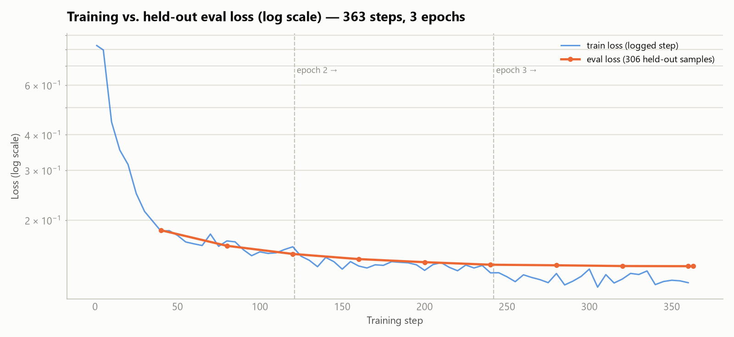
Epoch | Mean train loss (logged steps) | Min | Max
1 | 0.248 (skewed by the first few warmup steps) | 0.150 | 0.827
2 | 0.139 | 0.130 | 0.149
3 | 0.124 | 0.116 | 0.134

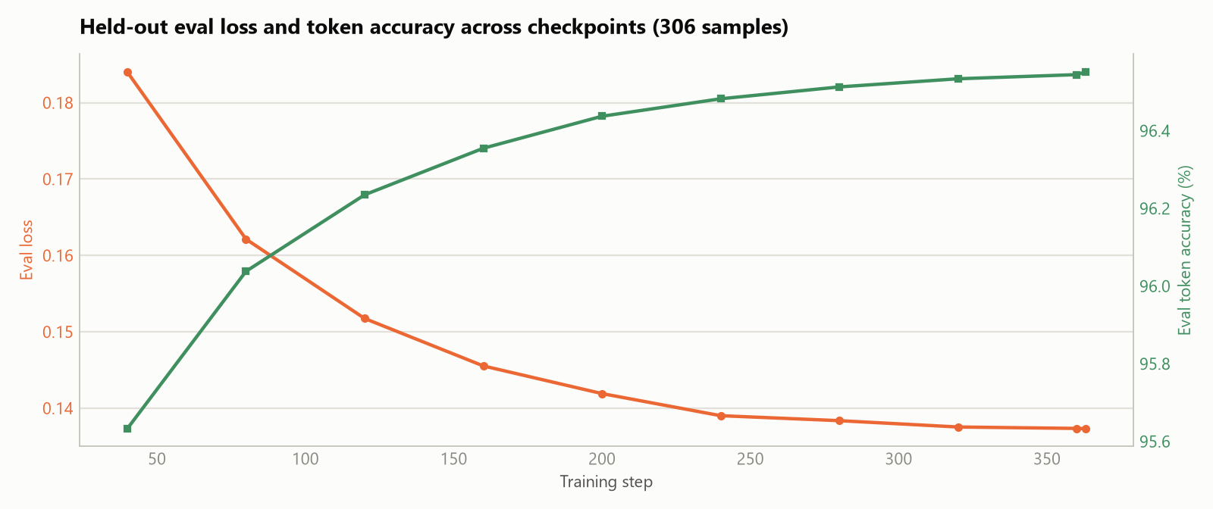
Step | Epoch | Eval loss | Eval token accuracy
40 | 0.33 | 0.184 | 95.63%
80 | 0.66 | 0.162 | 96.04%
120 | 0.99 | 0.152 | 96.23%
160 | 1.32 | 0.146 | 96.35%
200 | 1.65 | 0.142 | 96.44%
240 | 1.98 | 0.139 | 96.48%
280 | 2.31 | 0.138 | 96.51%
320 | 2.65 | 0.137 | 96.53%
360 | 2.98 | 0.137 | 96.54%
363 (final) | 3.00 | 0.137 | 96.55%

Because this run has a genuine held-out eval split, both curves can be checked against each other directly. Train and eval loss fall together throughout the run with no divergence — the eval curve is never meaningfully above the train curve, and the best checkpoint by eval_loss is the final step (363), so there is no overfitting signal across the full 3 epochs. Loss drops fastest in epoch 1 as the model learns the rigid JSON output template, then flattens into a floor around 0.137 (eval) / 0.124 (train) by epoch 2, with only marginal further gains in epoch 3 — expected diminishing-returns behavior under cosine LR decay, not a stall. Eval token accuracy rises in lockstep from 95.6% to 96.55%. The warmup spike here (loss 0.83 at step 1) is far milder than the sibling main.py run's (~4.3, with grad_norm: NaN for the first 3 logged steps) — this run trains in bf16 rather than fp16 and never hits that early instability, so the trainer-reported aggregate train_loss (0.124) closely tracks the epoch-3 mean rather than being skewed by a warmup spike.

6.3 Learning-rate schedule
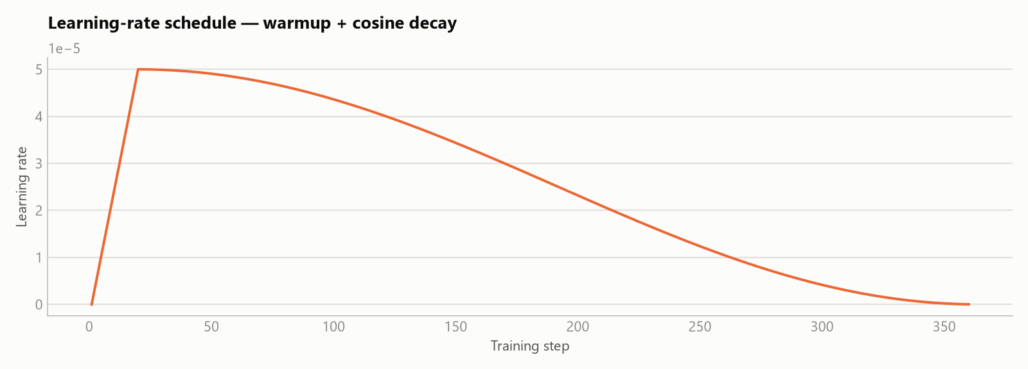
Warmup over the first 5% of steps to a 5e-5 peak, followed by cosine decay to ~0 over the remaining steps — visible directly in the loss curve's soft convergence across epochs 2–3.

6.4 Compute
Total steps | 363 (121/epoch × 3 epochs)
Total training time | 41,177 s ≈ 11.4 hours
Throughput | 0.423 samples/s, 0.009 steps/s
Total FLOs | 3.88 × 10¹⁷
Checkpointing | every 40 steps, best 3 kept; best-by-eval_loss checkpoint (step 363) restored at end

A single L4 GPU, bf16 + gradient checkpointing, pushing an effective batch of 48 through 1,024-token sequences for ~11.4 hours to complete 3 epochs over the 6,109-record set plus a 306-sample eval pass every 40 steps — a modest, single-GPU LoRA fine-tune, faster wall-clock than the sibling main.py run despite the added eval overhead (14.7 hours), consistent with bf16 vs. fp16 throughput differences on this hardware.

7. Notes and caveats
- Canonicalization is a value-level relabeling pass over the exact same 6,109 clean records — no records were added or removed, so §3's corpus/job ledger from the *.clean.jsonl report carries over to this dataset unchanged.
- table_type is still a long-tail, open-vocabulary taxonomy after canonicalization: 2,087 distinct strings across 6,109 records. Canonicalization closed 145 near-duplicate variants (2,232→2,087) via 420 remapped cells, but did not collapse the taxonomy to a fixed enum.
- concept_meaning canonicalization only resolves concept_ids with a dominant (≥60%) meaning share; 17,211 concept_ids remain ambiguous and were left as free text — a candidate area for further normalization if concept-level accuracy matters more than structural accuracy.
- Unit canonicalization applied only a 3-entry alias map; 32 additional mixed-scale unit variants (several hundred cells each, e.g. million HUF, EUR_thousand) were flagged but not auto-fixed and remain as separate unit strings in the training data.
- This run used a genuine 5% held-out eval split (306 samples) with load_best_model_at_end=true — reported metrics reflect real generalization, not just training-set fit. Contrast with the sibling *.clean.jsonl / main.py run, which had eval_strategy: no and reports training loss only.
- The train/eval loss floor here (~0.124 / ~0.137) is notably higher than the sibling run's near-zero training loss (~0.025–0.03). Given the sibling run had no eval split, its lower number most likely reflects the raw (non-deduplicated-for-label-consistency) file being easier to fit/memorize, with no held-out check to catch that — it is not evidence that run generalizes better.
- Full raw statistics backing this report are in report_assets_adapter1/stats_adapter1.json; regenerate with report_assets_adapter1/analyze_adapter1.py (dataset stats), report_assets_adapter1/chart_gen_adapter1.py (dataset charts), and report_assets_adapter1/train_chart_gen_adapter1.py (training-run charts).

